NAME

ADDRESS

DATE

**Notice of intent to not pay your made up tax !**

To Jonathan Stephenson in his private capacity who sometimes acts as **CEO employee of Brentwood Borough Council**.

I inform you I will no longer be paying council tax for the following reasons.

1. Under UK tax laws you can only charge tax for commerce. - Duty, Excise and Impost.   
   I am not running a business at my property nor do I earn an income from here.
2. The court summons you issue are Fraudulent (Local Government Act 1888 78-2) and designed to intimidate and put fear into people. They are also breaching the Forgery and counterfeiting act 1981 Section 3
3. The court room that you hire in Basildon magistrates court has no case files for my court case. I have the evidence. This is against court rules and due process.
4. There is no evidence of a liability order materialized after many DSARS
5. Brentwood Borough Council is a “for profit” Company listed on dun and bradstreet.   
   This means I have to contract with them.   
   I never once was asked if I wanted their services.   
   I have only been forced to pay as I used to be scared into paying.   
   I have had money extorted by this company.
6. The council has no lawful authority to tax me.
7. The Bill of rights act 1688. No fines and forfeitures before court…..Basic stuff really
8. Seven Arches Investments…..Say no more. That’s tommorows project to look into to. Amazing what you can find out on the internet.
9. The council tax is inequitable. A contract (if I had one) would need to be equitable and quite simply its not. The fact is there is no such thing as a council tax contract.
10. I don`t want to.
11. I can`t afford to.

If you can convince me why my 11 points raised above are not true or valid then I will pay.

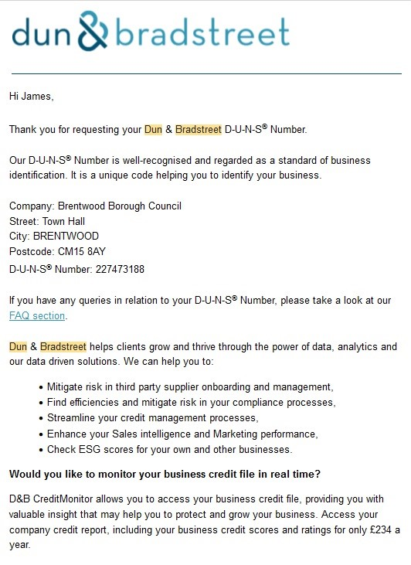

Please also be aware that this is private property and I remove my implied right of access to you, any of your employees, contractors or associates. Any one stepping foot on my property will be liable for aggravated trespass. Under Criminal Justice and Public Order Act 1994 68 -1.

All rights reserved, without prejudice, without recourse, none assumption.  
I will also send this request via signed for mail and keep the receipt.

Thank you,

NAME HERE AND SIGN A PAPER COPY