**Everything in red is from The Bank to you**

**Everything in Black is from you to the Bank**

*1st September 2021 – Data Subject Access Request (DSAR) to the bank. A reply needs to be received by you within one month of receipt by the bank*

*24th September 2021 – Letter from the bank to confirm receipt of the DSAR*

*1st October 2021 - Mortgage not paid.*

1st October 2021 - Text received from the bank at 08:45 (You’re using an unarranged overdraft. Please pay cleared funds in by 2.30pm to keep making payments.

1st October 2021 - Letter Notice 1 sent to Charlie Nunn recorded

4th October 2021 - Letter (online) received from the bank dated 1st October 2021 ‘some of your payments haven’t been made’

5th October 2021 - Letter received from the bank ‘we couldn’t collect your payment’

7th October 2021 - Text received by the bank

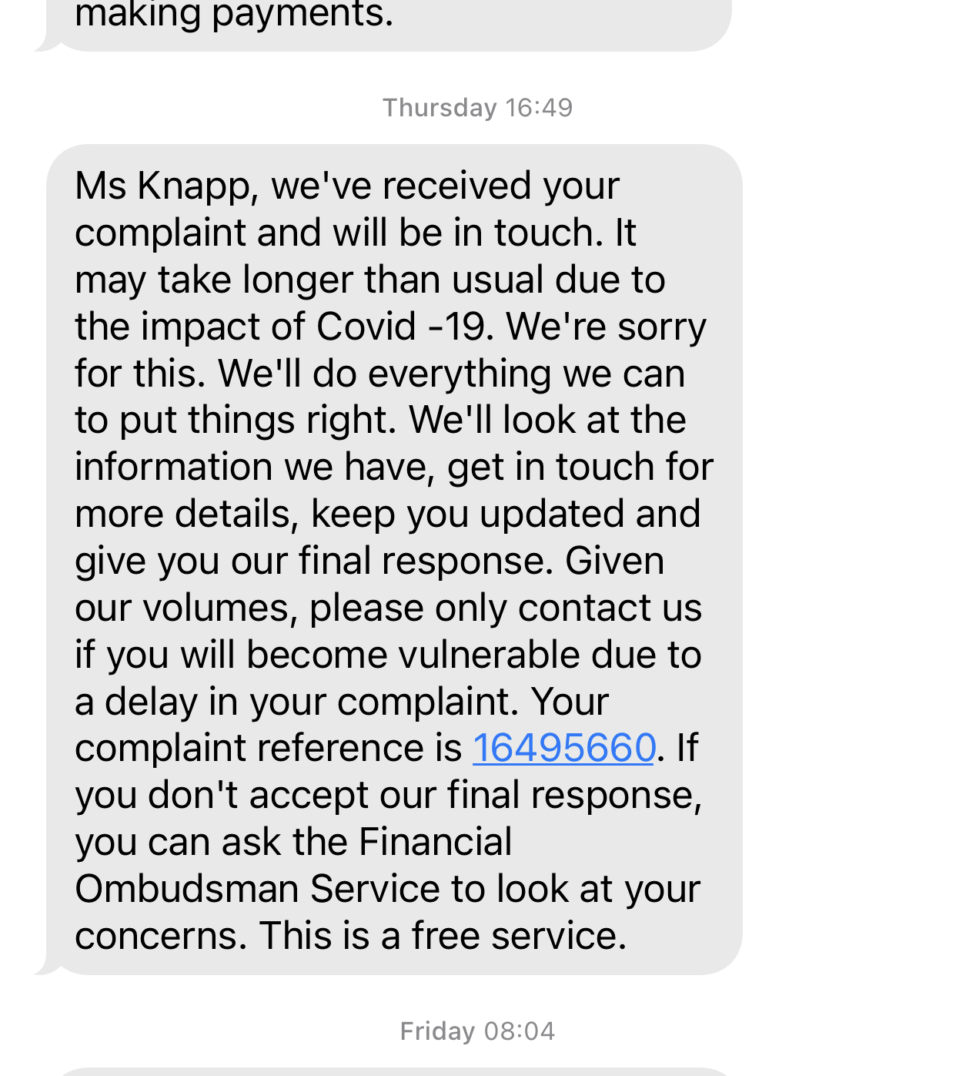

8th October 2021 - Text received by the bank

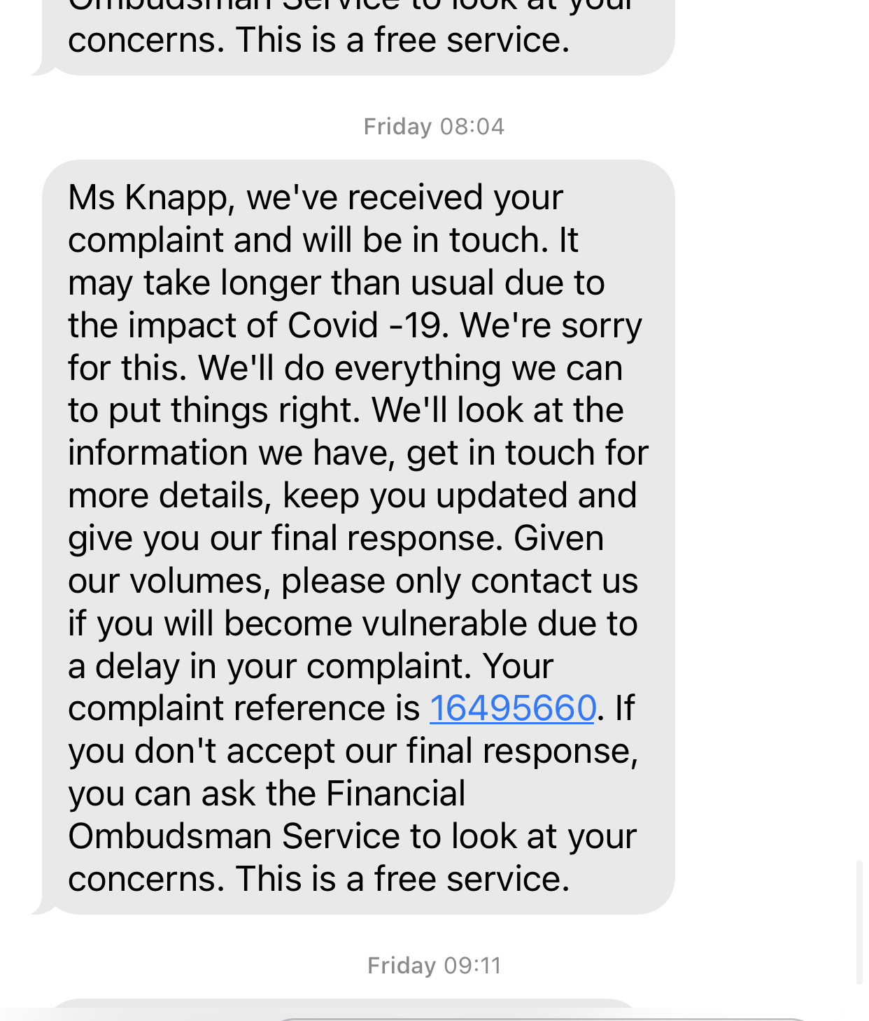

14th October 2021 - Letter received from the bank DSAR Team dated 12th October 2021

15th October 2021 - Text received from the bank at 09:11

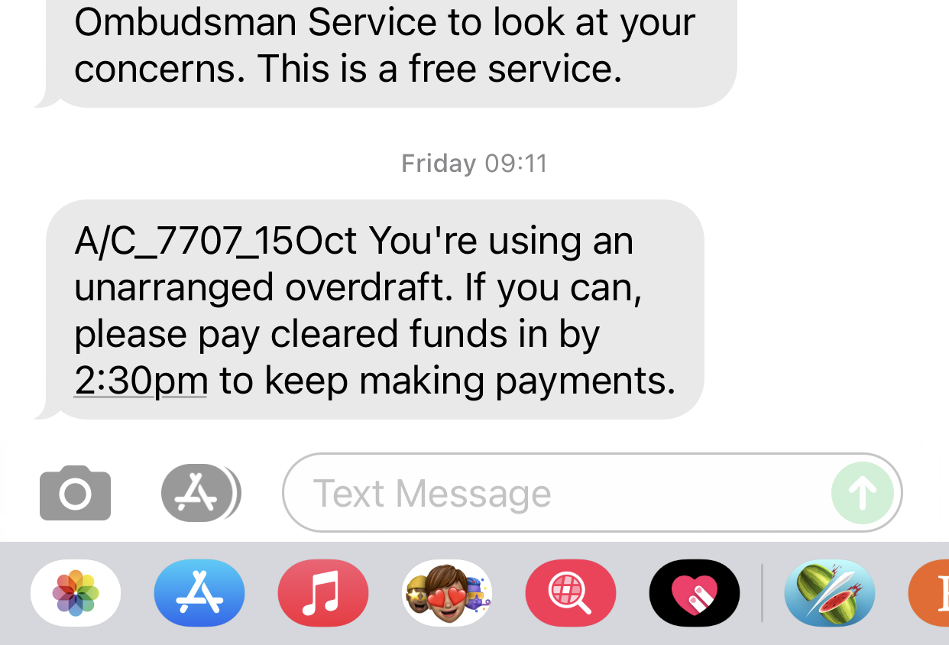

15th October 2021 - Received letter from the bank ‘some of your payments haven’t been made’ (online letter)

15th October 2021 - Letter received from **Daniel Smallman** (1st Interloper) ‘We’ve looked into your complaint’ – Even though it wasn’t a complaint!

18th October 2021 - Email received from the bank at 22:40 linking to online letter dated 15th October 2021 - from Daniel Smallman replying to my letter to Charlie Nunn (notice 1).

20th October 2021 - Reply sent to the bank DSAR Team by me recorded – Reference number: KL45887234GB – It was signed for by “Jones” at 09:20am on 22nd October 2021

21st October 2021 - Text received from The bank at 15:30

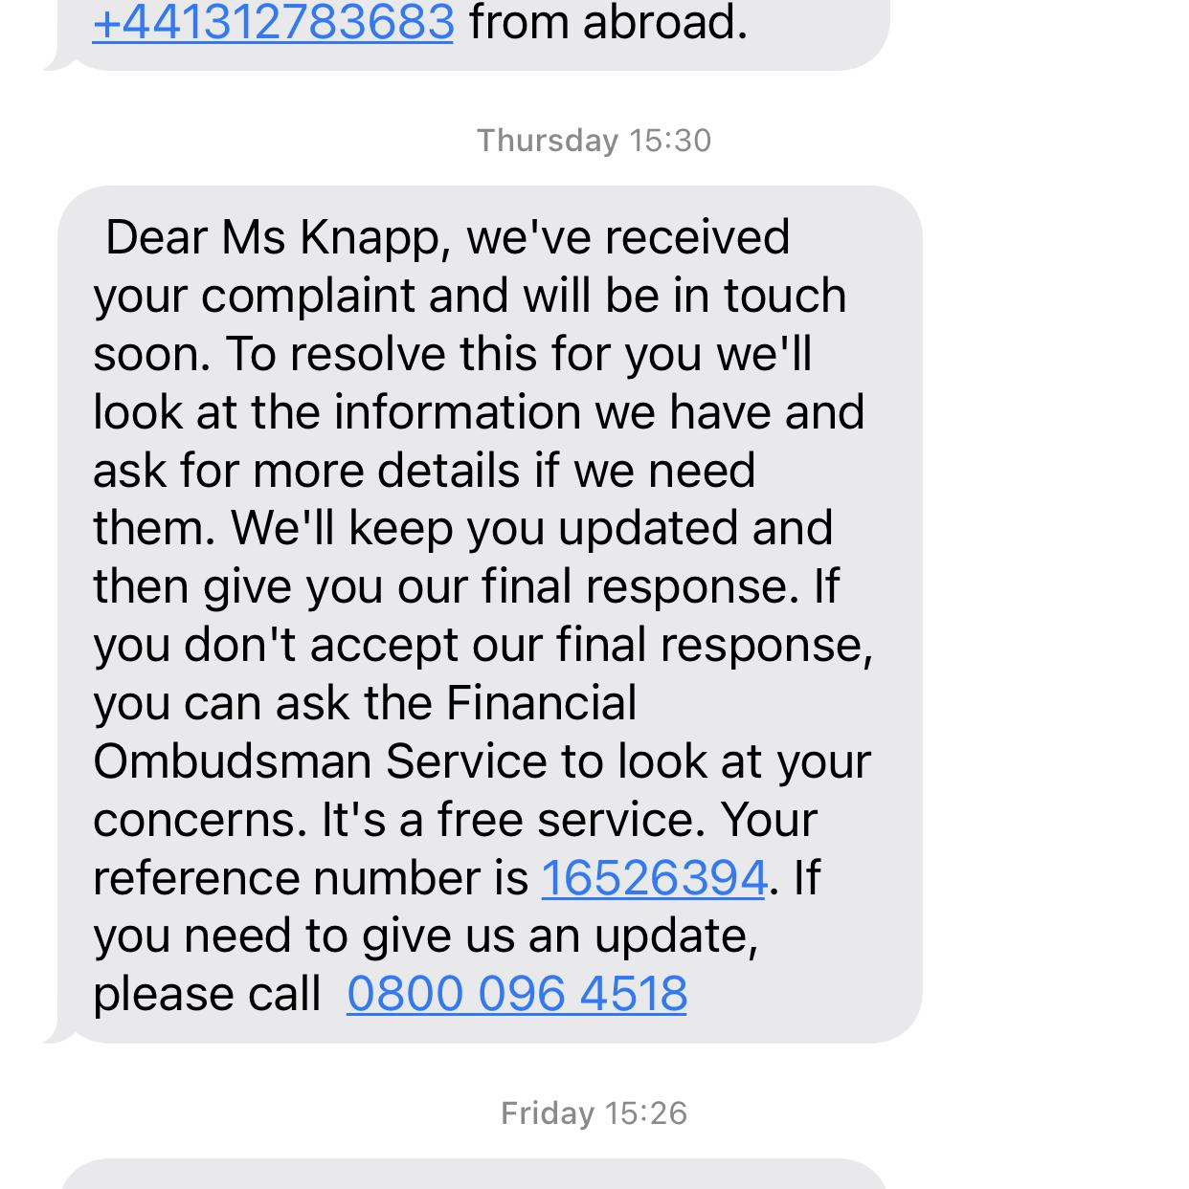

22nd October 2021 - DSAR bundle arrived - doesn’t include phone calls or emails.

23rd October 2021 - Letter received dated 22nd October stating ‘we have changed your address’ - I telephoned the bank and had a conversation to ensure all correspondence comes to me as well, and for this to be put in writing. Also that any letters sent from me personally and to be treated as private and confidential and only sent to me. Also asked for this in writing.

25th October 2021 - Text received from the bank at 08:23

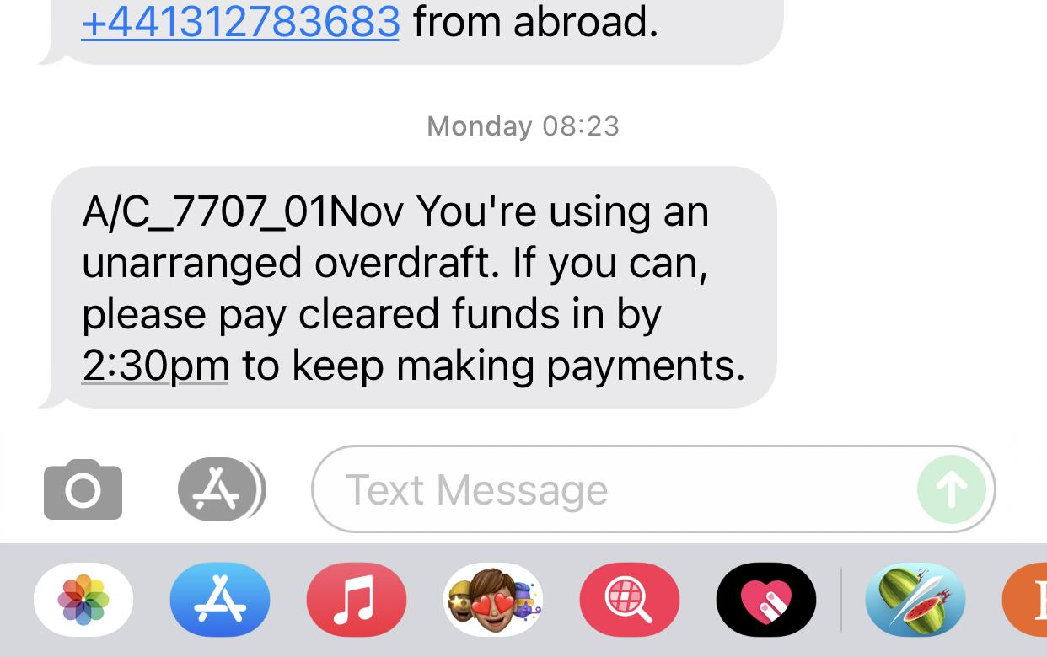

29th October 2021 - Notice 2 sent to Charlie Nunn recorded

29th October 2021 - Reply retort letter sent to Daniel Smallman who interloped my letter to Charlie Nunn (notice 1) - recorded.

*1st November 2021 - Mortgage not paid*

1st November 2021 - Text received from the bank 08:23

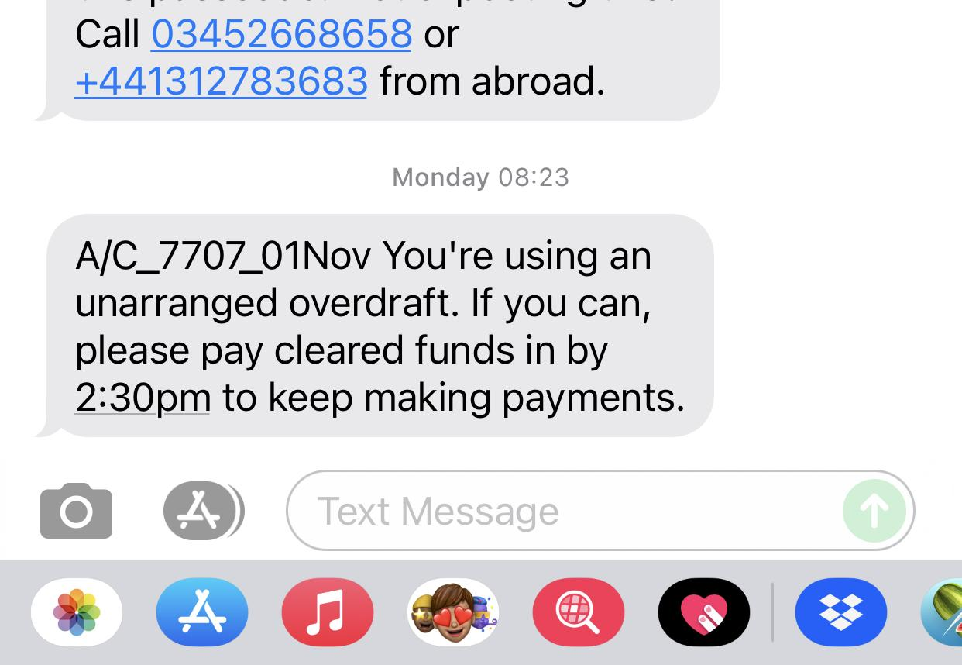

1st November 2021 - Received letter from the bank‘some of your payments haven’t been made’ (online letter)

2nd November 2021 - Received letter from the bank ‘we haven’t received a mortgage payment’

3rd November 2021 - Letter from the bank ‘we couldn’t collect your mortgage payment’

4th November 2021 - Received letter dated 4th from **Daniel Bigman** (Interloper) (2nd letter from him in reply to my retort to him)

5th November 2021 - Received DSAR information again with potentially 1 additional piece from a 2012 request for PPI

6th November 2021 - Received letter from **Nikki Icke** (2nd Interloper) dated 2nd November 2021 at the bank re ‘your complaint with us…’

8th November 2021 - Retort letter 2 sent to Nikki Icke - recorded.

8th November 2021 Letter received from **Nikki Icke** (2nd Interloper) letter dated 3rd November 2021 ‘we’ve looked into your complaint’ - thanking me and in reply to my letter dated 1st October 2021.

12th November 2021 - Received letter dated 12th (on 22nd November 2021) confirming ‘when a request is received by you, we will respond directly to you’

15th November 2021 - Text received from the bank at 08:54

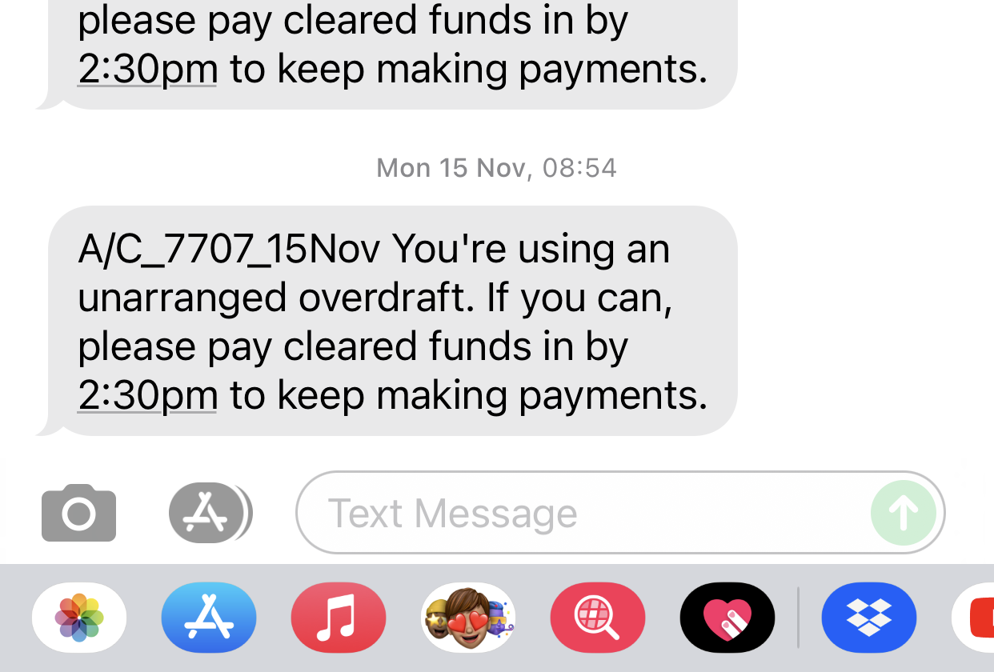

15th November 2021 - Received letter from the bank ‘some of your payments haven’t been made’ (online letter)

17th November 2021 - Sent 3rd Notice to Charlie Nunn

17th November 2021 - sent letter /retort 3 to Daniel Smallman

22nd November 2021 - Received letter from **Nikki Icke** (pp’d) dated 3rd November - ‘We’ve looked into your complaint’ again.

29th November 2021 - Letter from **Debby Morris** (3rd Interloper) ‘we’ve looked at your complaint’ - thanking for letter to Charlie Tubbs and referring to her colleague’s letter of 3rd November 2021. Also saying that they would no longer be responding to my letters, they would be kept on file.

*1st December 2021 - Mortgage paid by John*

1st December 2021 - Text received from the bank at 07:12

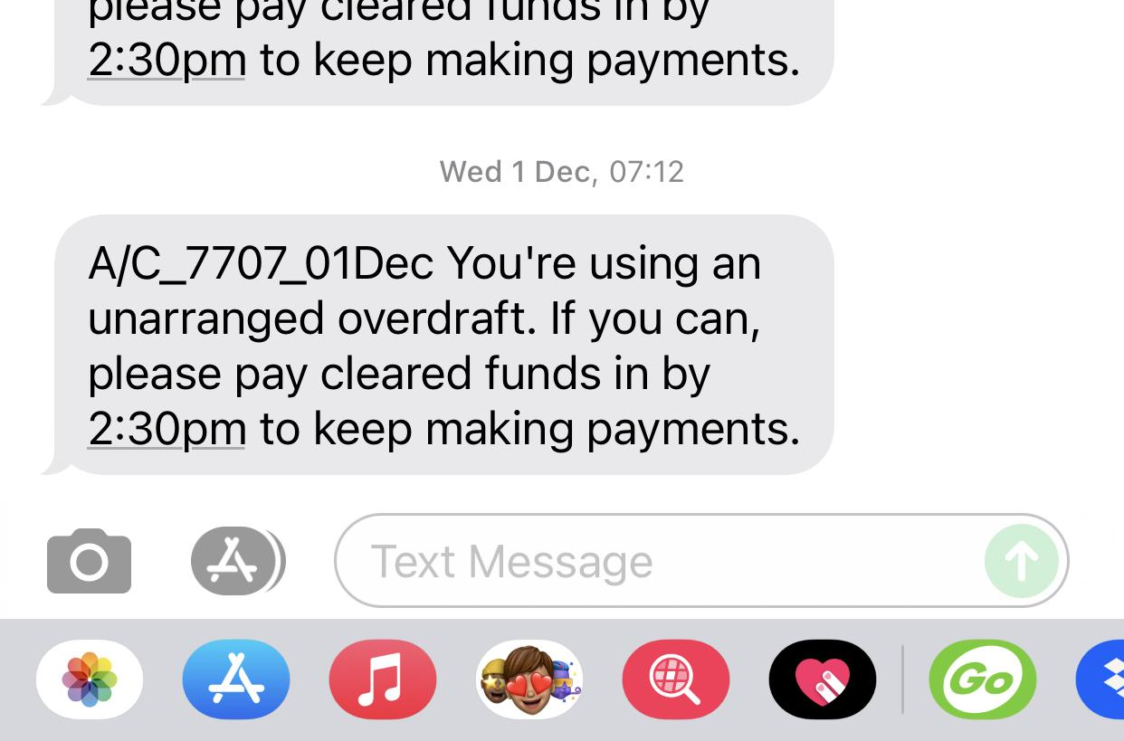

1st December 2021 - Received letter from the bank ‘some of your payments haven’t been made’ (online letter)

3rd December 2021 - Received letter from the bank ‘we couldn’t collect your mortgage payment’ - Even though John had now paid the arrears and paid this month's mortgage payment.

13th December 2021 - Retort letter sent to Debby Morris.

**End of Examples – Keep your own Correspondence log like the one above. Add to it each time an email, text or letter comes in. It could be vital, so keep the log up to date! Save the file as: “Bank or DCA name, Your Name correspondence log {date} 16:40” If you send it to anyone, save it as a pdf.**