**MR D Smith One Source Enforcement   
Onesource Enforcement Services,  
Newham Dockside,  
1000 Dockside,  
London  
E16 2QU**

**OneSourceEnforcementServices@onesource.co.uk**

**13 September 2024**

**CUSTOMER REFERENCE:** 41******** **Rebuttal of your claim.**

Dear Mr D Smith

I write regarding the alleged debt which is null and void for several reasons.

* The “Liability Order” you have is a council document not a court document. Since 2003. This is Fact and case precedent has been set. I have proof from freedom of information request from HMCTS

The “Basildon Magistrates court” Hires out the venue and uses it as a business. This is confirmed by the Court -   
<https://www.youtube.com/watch?v=Mw6bL_TmlZ8> It does not follow due process of law, this is against the human rights act: Article 6: Right to a fair and public hearing. Also against the Observance of due process of law 1368, The Bill of rights act 1688 I could go on…..Actually I will go on

* Brentwood is a company and has no legal contract with me.
* The Local council should not be funded by Local people but by Income Tax.
* The MOJ ***Ministry of Justice*** has responded to my Data Subject Access Request and confirmed there is no court case files for this case. This makes your claim void.
* This is a civil matter and got nothing to do with you.
* If I was to pay the council tax I would be aiding and abetting crime committed by the council which I will not do
* According to Basildon Magistrates court the council does the paperwork, however the council is the Claimant !! Hilarious. FUCK OFF.
* I am a beneficiary, The Council is the trustee. They serve me in law. Not vice versa.
* If that mug turns up again hes gonna get it.
* I REPEAT I REMOVE YOUR IMPLIED RIGHT OF ACCESS. If you try to extort me again on my private property I RESERVE THE RIGHT TO REMOVE YOU BY FORCE. You will probably get injured, This is your final warning.
* One Source was dissolved on companies house in February 2022 ? WTF you fucking idiots think I paying you. You are stupider than you look. And you look very stupid. Look like a nonse case to me actually for the record. <https://find-and-update.company-information.service.gov.uk/company/11451990>  
    
  You cannot gain entry for a civil matter, If anyone tries to break in my house they will be very sorry, very quickly. This is a warning to you. I will defend my house and private abode with whatever force I feel is needed.
* You have no rights to take any of my property without my permission and that certainly won`t be given. I don`t own any goods and all my property is in private trust ha ha ha ha
* You will not be let onto my property; I will not even answer the door and confirm my name.
* You are not a bailiff and even if you were your claim is void. I will not be intimidated by you like most people are. I know the law and I will enforce it.

You are now given notice **AGAIN** that **I remove your implied right of access**. This basically means “fuck off” and ignoring it breaches my right to privacy and is considered harassment, Anyone from your company or “service” has no right to breach my peace.

**Cease and desist contacting me immediately** or I will take action against you in your private capacity. I have already told your company this on the 17th of January 2024. Also in April, They obviously ignored and sent you anyway. Tresspassing.My home security is always recording, I am giving you notice this will be used in evidence if need be.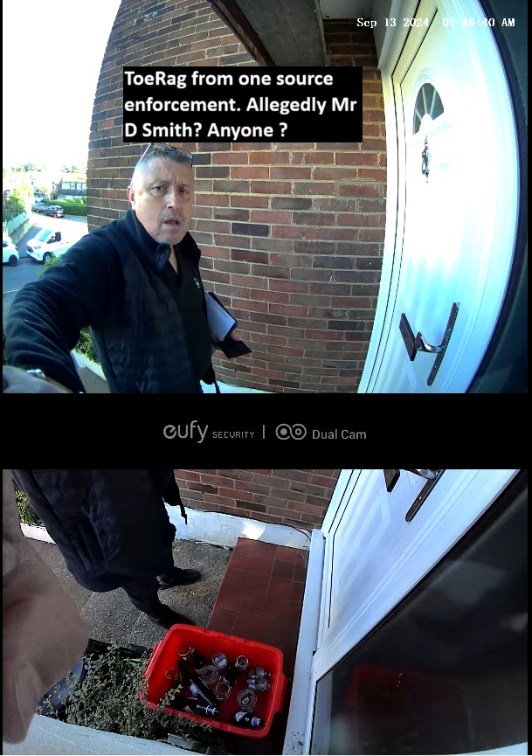

I suggest you send alleged debt back to Brentwood Council / Basildon Magistrates Tell Johnathan Stephenson the CEO. I`m not paying his fake tax. Ever. I don`t care about any Fake Fraudulent debt collectors, including yourself, I will not pay for an illegal tax that funds wars and this corrupt system. The consolidation fund is paid for with council tax. I don’t consent.

If you step one foot on my property again, I`ll assume you are here to extort money from me and I will remove you forcefully or restrain you until the police arrive and you will be arrested for extortion and Fraud. If you attend here you do so at your own risk and I cannot be held responsible for any loss, damage or injury sustained whilst you are on my property.

PS Your “Company” was dissolved on companies house in July 2022.

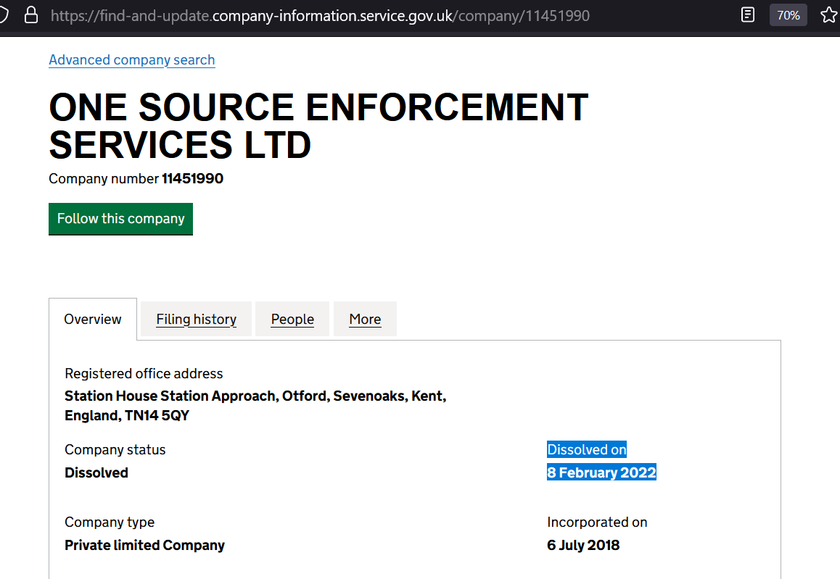

Thanks, but no thanks, Fuck off, leave me alone and stop harassing me with texts, letters, emails and mugs at my door.

You are breaching the Peace, go and pick on some other stupid unenlightened person you nasty little extortionist.

If I hear from you again, I will litigate. So just to be 100% Clear. FUCK OFF

Attached is the evidence the “Liability order” is a council document.   
One Freedom of information request & one DSAR, both from the ministry of Justice.

If you bother me again I will sue you personally.

This letter is being posted on youtube along with your shady video. I hope you are proud of yourself you know exactly what you are doing and its very wrong. I hope you feel ashamed of yourself.

Keep Away from me. Third and final warning. I know who I am and I know who you are. You would do well to fuck off.

Jim